**[CREATE AND CONFIGURE IBM CLOUD SERVICES](https://careereducation.smartinternz.com/Student/guided_project_workspace/22094" \l "collapse2)**

**PNT2022TMID02383**

### 1) Create IBM Watson IoT Platform and Device

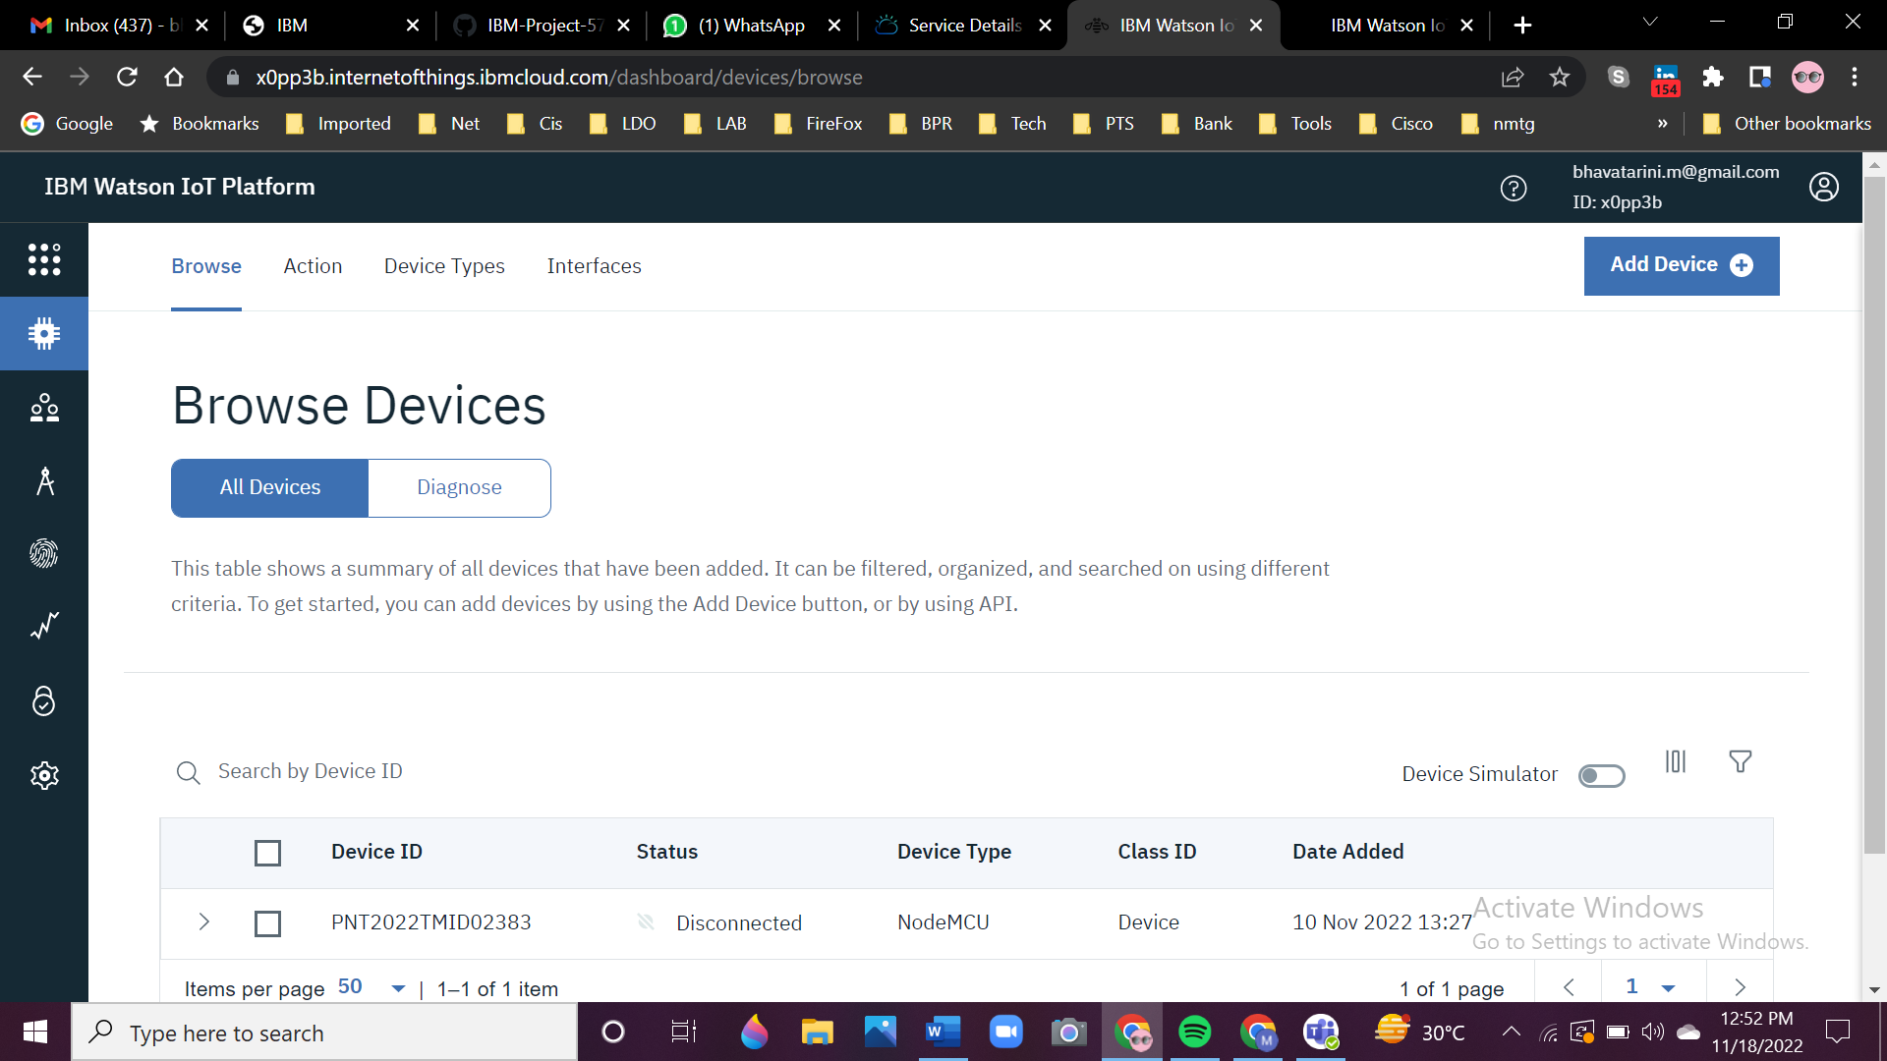

### 2) Create Node-RED Service

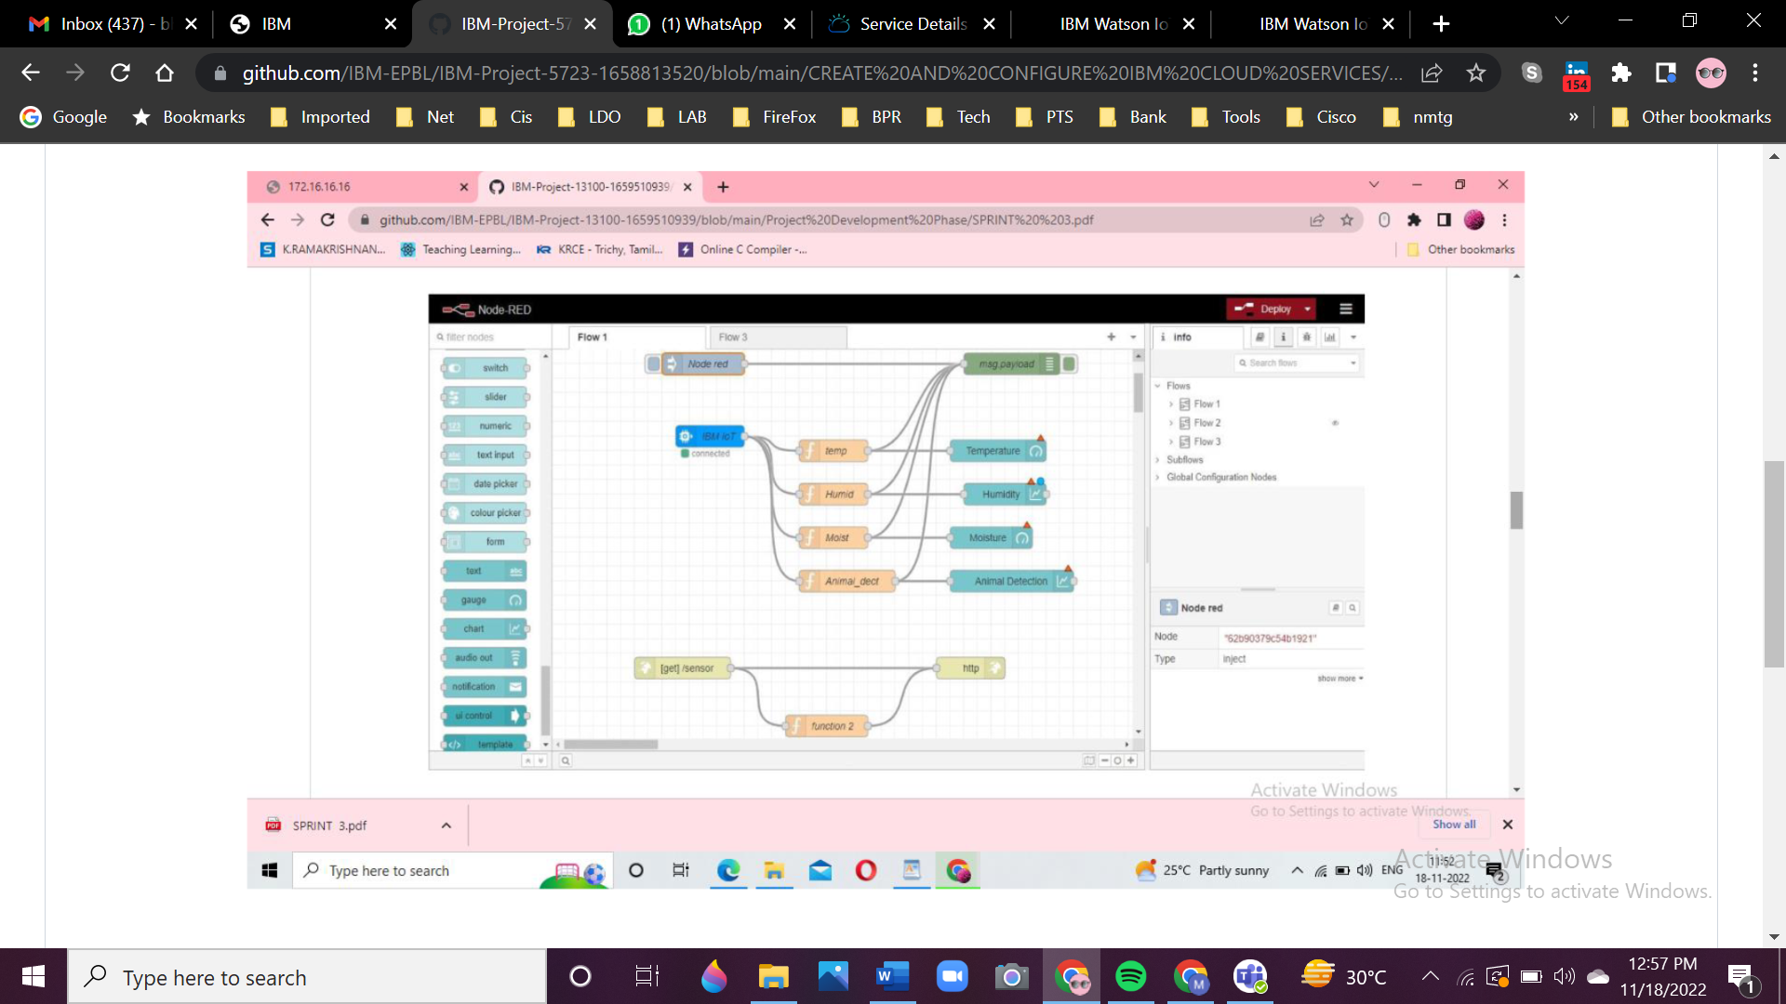

### 3) Create A Database in Cloudant DB

### 4) Create A Cloud Object Storage Service

